Data Flow Diagram
Date | 29 September 2026
Team ID | 6ab4cdb46603573ccfb546d2
Project Name | AI FAQ Assistant API
Team Members | Prathesha R, Keerthana A, Prasana Kumari D, Vijayalakshmi S
Maximum Marks | 2 Marks
Data Flow Diagram
Create a Data Flow Diagram (DFD) to show how data moves through your system - between external entities, processes, and data stores. Use the symbol legend below as a guide.
DFD Symbol Legend
Symbol | Name | Description
Oval / Rounded shape | External Entity | A person, organization, or system outside the project that sends or receives data (e.g., Customer, Payment Gateway).
Rectangle with numbered header | Process | An activity that transforms incoming data into outgoing data (e.g., Validate Request, Process Order).
Rectangle (solid fill, no number) | Data Store | A place where data is held for later use (e.g., Customer Database, Inventory).
Labeled arrow | Data Flow | The movement of data between entities, processes, and data stores, labeled with what data is being passed.
Example
The diagram below illustrates how the symbols above come together to form a complete data flow diagram.
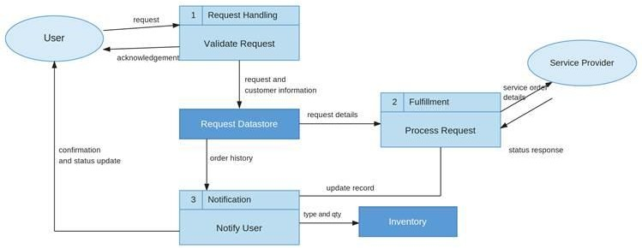

Data Flow Diagram - AI FAQ Assistant API
